1. Idnetify the error for the following programs,

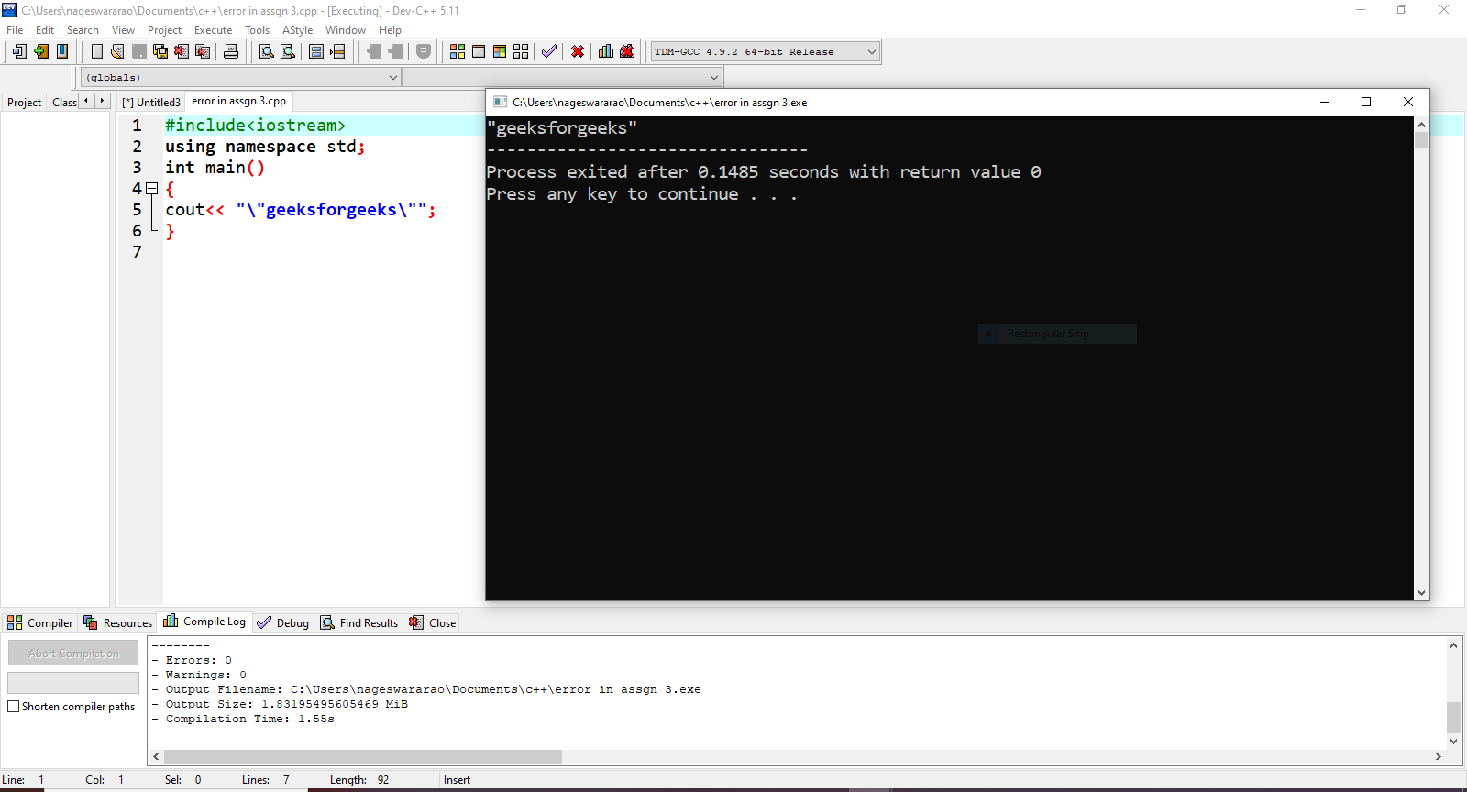

1. What will be the output of the following program

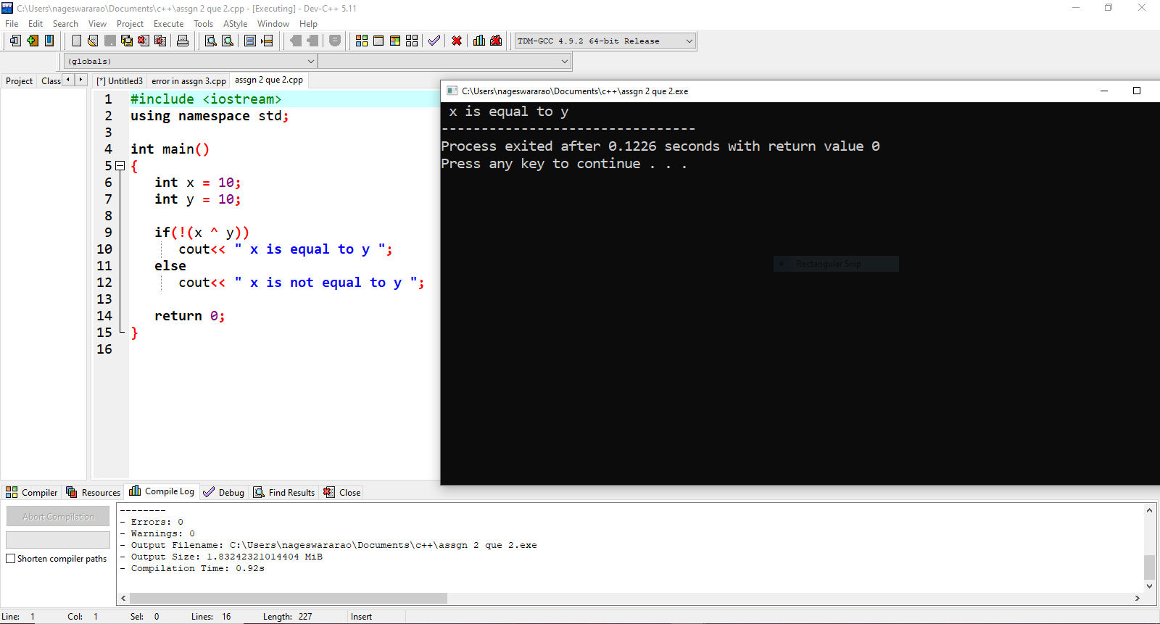

1. Find the output of the following program

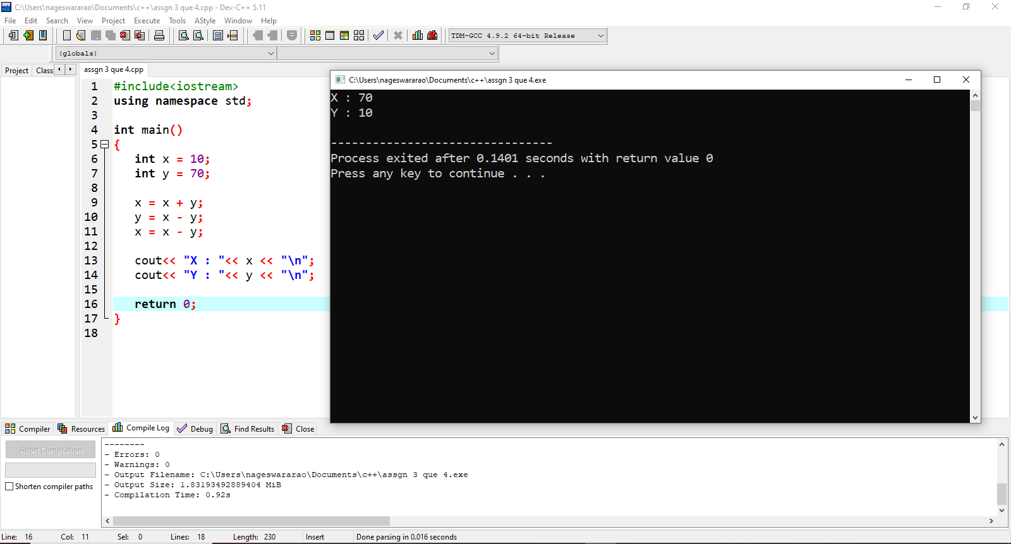

1. Identify the error / output of the program

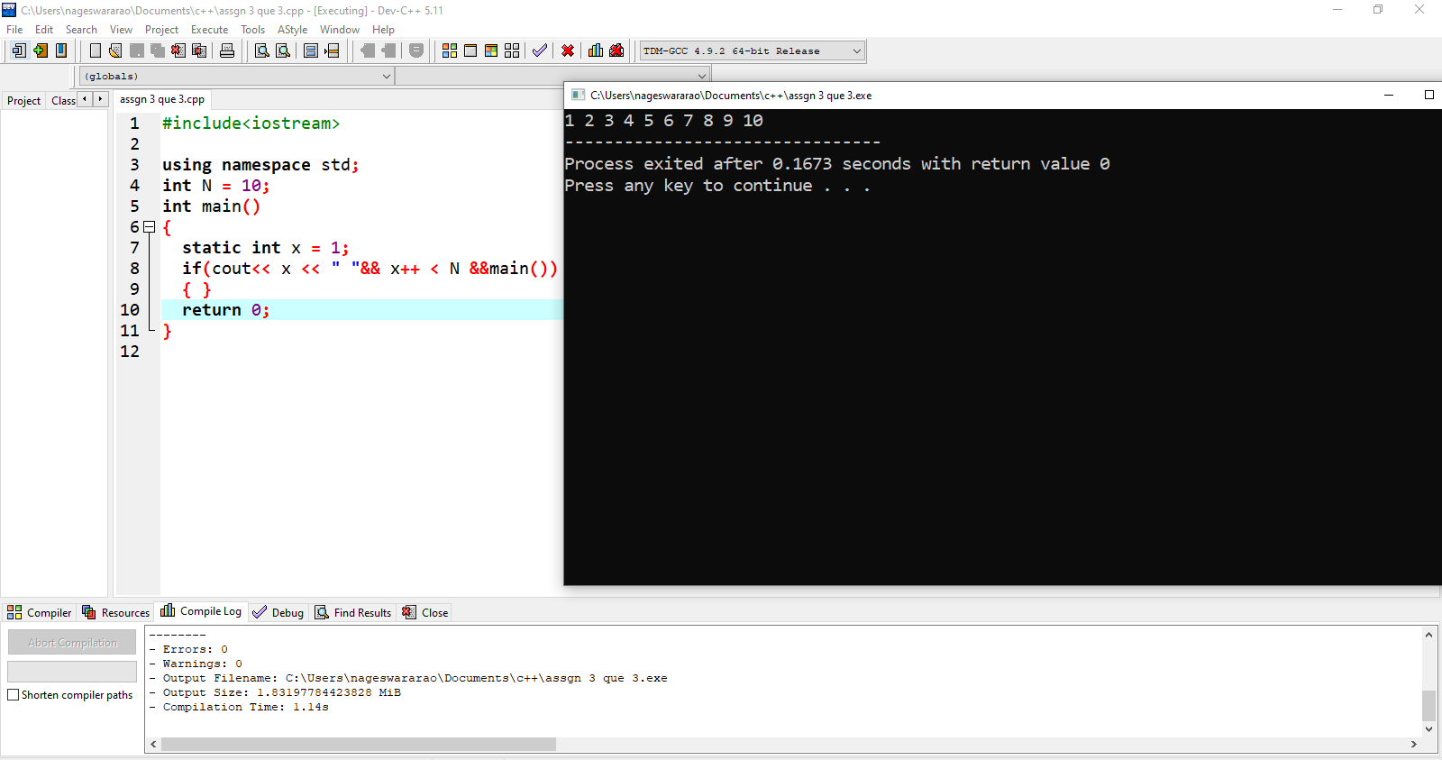

1. Can we do in C++ with this header file.

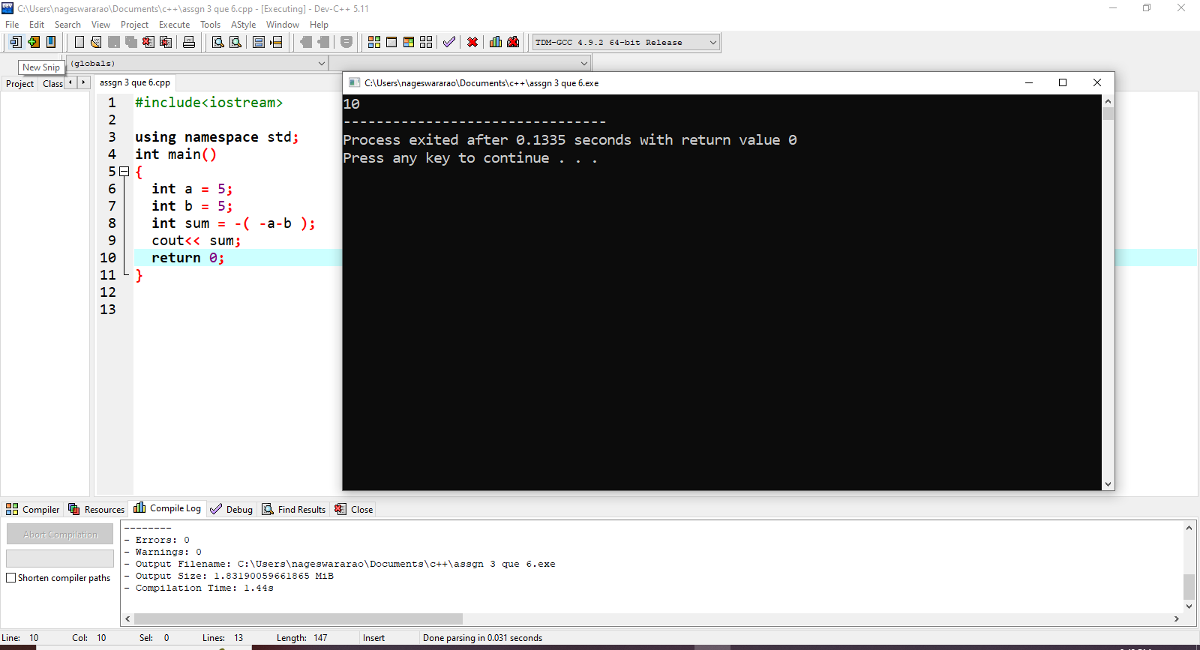

1. Find the output for the program.



1. What is the output

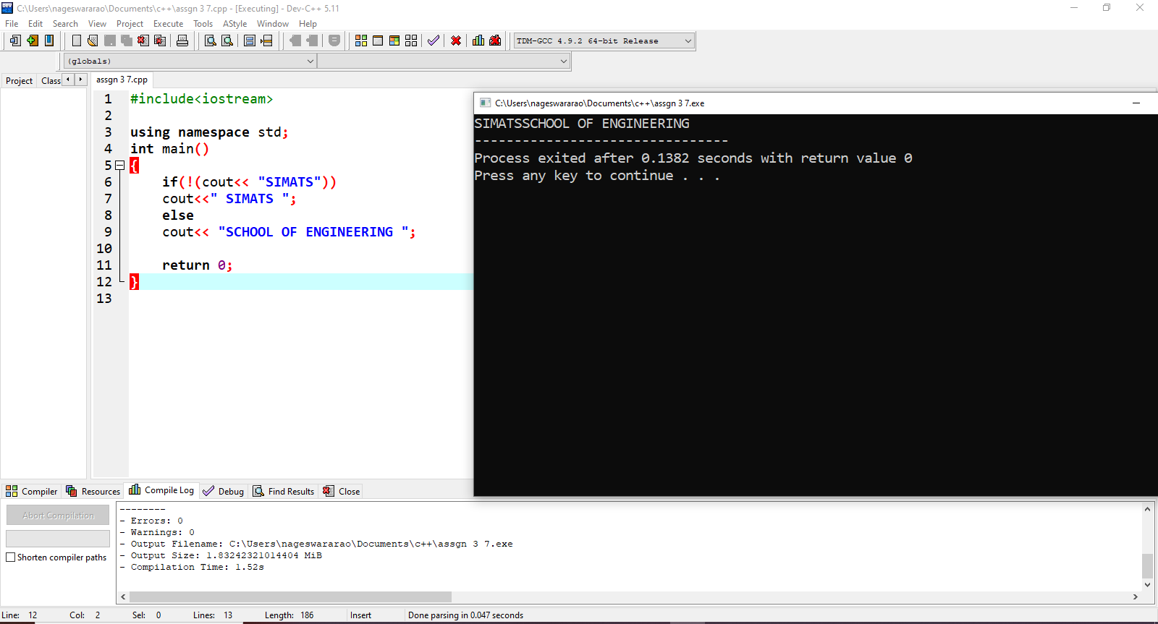

8. Find the output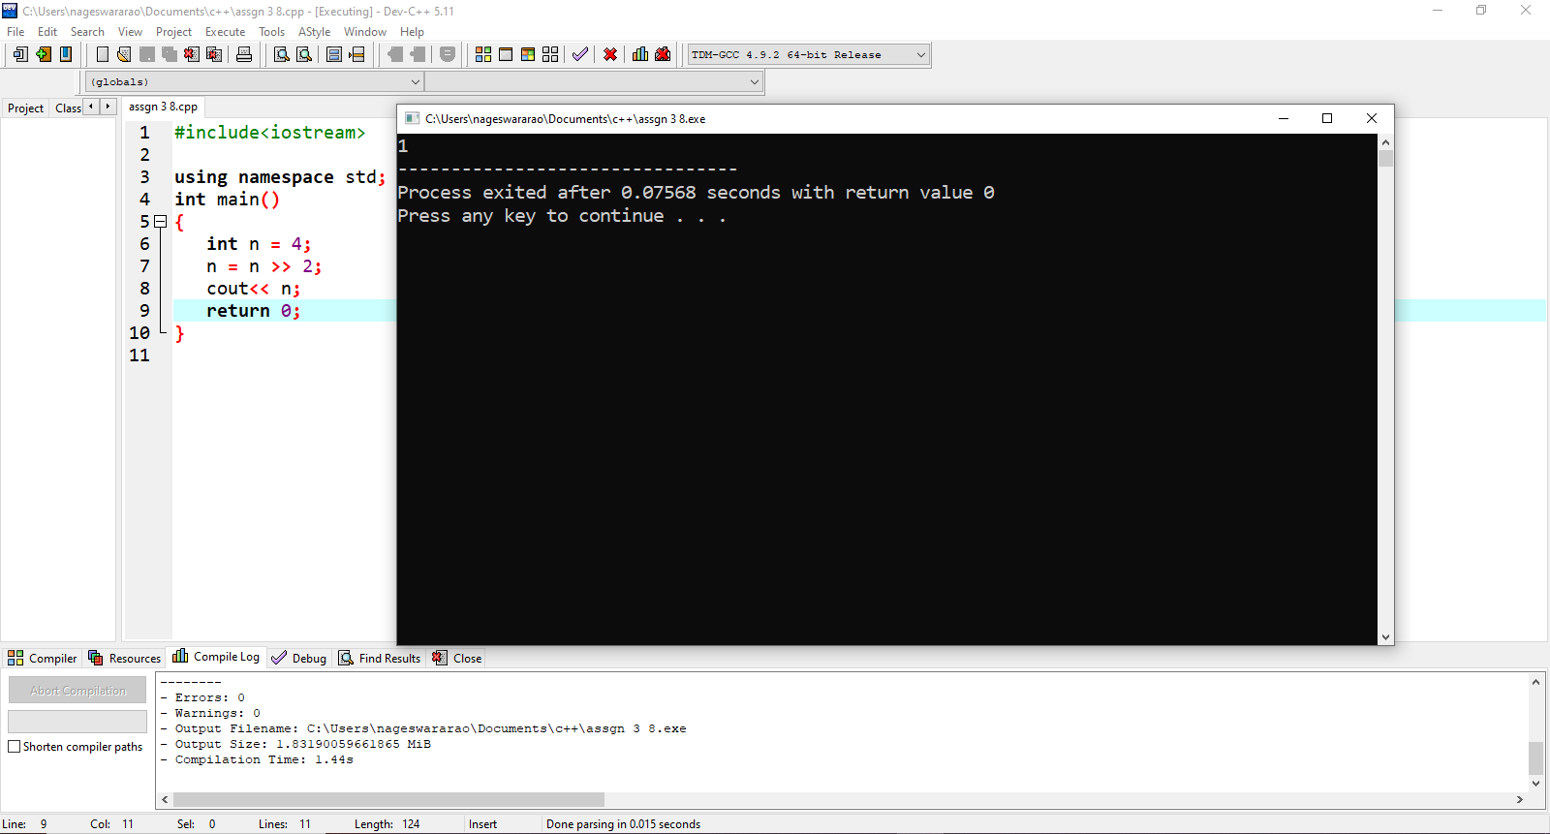

9. Find the output of following code: 

10. Find the output of following code: 